**LAB ASSIGNMENT 2**

1. Design a user registration form implementing internal css.

<!DOCTYPE html>

<html lang="en">

<head>

<title>web tech</title>

<meta charset="utf-8">

<meta name="viewport" content="width=device-width, initial-scale=1">

<style>

* {

  box-sizing: border-box;

}

body {

  font-family: Arial, Helvetica, sans-serif;

}

header {

  width: 500px;

  height: 200px;

  padding: 30px;

  text-align: left;

  font-size: 35px;

  border-style: solid;

 border-color: black;

}

nav {

  float: left;

  width: 200px;

  height: 300px;

  border-style: solid;

  border-color: black;

  padding: 20px;

}

nav ul {

  list-style-type: none;

  padding: 0;

}

section::after {

  content: "";

  display: table;

  clear: both;

}

@media (max-width: 600px) {

  nav, article {

    width: 100%;

    height: auto;

  }

}

</style>

</head>

<body>

<header>

  <h2>KIIT UNIVERSITY</h2>

</header>

<section style="width: 500px;border-style: solid;

border-color: grey;">

  <nav>

    <ul>

      <li><a href="https://kiitportal.kiituniversity.net/irj/portal/">Login</a></li>

      <br>

      <li><a href="https://kiit.ac.in">About KIIT</a></li>

      <br>

      <li><a href="https://www.amazon.in/?tag=operadesktop-21">Feedback</a></li>

    </ul>

  </nav>

</section>

</body>

</html>

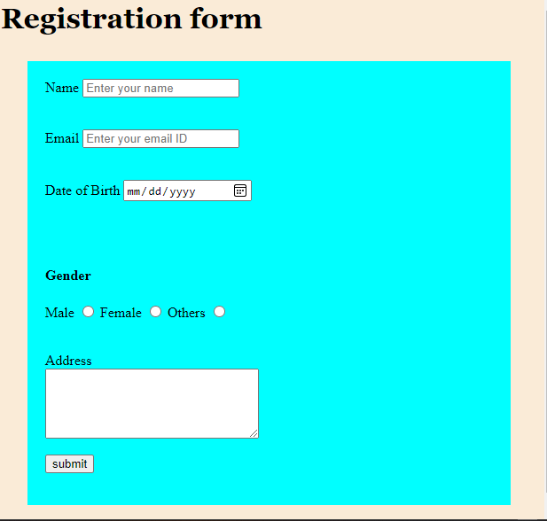

2. Create a web page as follows: having 3 frames. KIIT University will move

in marquee in the top frame. In the left frame, 3 hyperlinks named Login, About KIIT and Feedback will be there and clicking on that the desired result will be displayed in the main frame.

Output:-

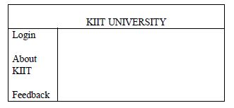

<!-- User registration form implementing internal css -->

<html lang="en">

<head>

    <meta charset="UTF-8">

    <meta http-equiv="X-UA-Compatible" content="IE=edge">

    <meta name="viewport" content="width=device-width, initial-scale=1.0">

    <title>Document</title>

</head>

<body style="background-color: antiquewhite;" >

    <h1 style="font-family: Georgia, 'Times New Roman', Times, serif;">Registration form</h1>

    <div style="background-color: aqua; margin: 30px; padding: 20px;">

    <form action="mailto: sharmakaustav04@gmail.com">

        <label for="name">Name</label>

        <input

        type="text"

        name="NameField"

        id="name"

        placeholder="Enter your name"

        required

        />

        <br>

        <br>

        <br>

        <label for="email">Email</label>

        <input

        type="email"

        name="EmailField"

        id="EMail"

        placeholder="Enter your email ID"

        required

        />

        <br>

        <br>

        <br>

        <label for="DOB">Date of Birth</label>

        <input

        type="date"

        name="DOBField"

        id="DOB"

        placeholder="dd/mm/yy"

        required

        />

        <br>

        <br>

        <br>

        <br>

        <h4>Gender</h4>

        <label for="Gender">Male</label>

        <input type="radio" name = "GenderField" id="Gender"/>

        <label for="Gender">Female</label>

        <input type="radio" name = "GenderField" id="Gender"/>

        <label for="Gender">Others</label>

        <input type="radio" name = "GenderField" id="Gender"/>

        <br>

        <br>

        <br>

        <label for="message">Address</label>

        <br>

        <textarea name="message"

            id="msgField"

            rows="5"

            cols="30"

        ></textarea>

        <br>

        <br>

        <input type="submit"

        name="submit field"

        id="submit"

        value="submit"/>

    </form>

</div>

</body>

</html>

